**ONLINE CAR RENTAL SYSTEM**



**BTech/III Year CSE/V Semester**

**15CSE302/Database Management Systems**

**Project Review -2**

|  |  |
| --- | --- |
| Roll no | Name |
| CB.EN.U4CSE18224 | **G. Hema Chowdary** |
| CB.EN.U4CSE18240 | **N. Haswanth Rajesh** |
| CB.EN.U4CSE18243 | **P. Yaswanth Ram** |
| CB.EN.U4CSE18270 | **T. Bhavana Reddy** |
|  |  |

**Amrita School of Engineering, Coimbatore**

**Department of Computer Science and Engineering**

**2020 -2021 Odd Semester**

Table of Contents

**Chapter Title Page number**

Chapter 4 Normalization 4

Chapter 5 Creation of Tables 11

Chapter 6 User Interface Design 16

References 20

# Chapter 4 Normalization

➔ **Admin**(adminid,a_name,a_password,a_phoneno,a_emailid)

➔ **User**(custid,u_name,u_emailid,dob,gender,u_phoneno,address, u_password)

➔ **Cardetails**(carid,carno,carname,capacity,availability,cost/day,fueltype, carimage)

**➔ Enquiry**(questions)

➔ **Feedback**(rating)

➔ **Rentdetails**(rent_id,carid,country,city,startdate,enddate,custid)

➔ **Payment details**(paymentid,carddetails,advanceamt,taxamt,rent_id)

**Initial schema with all attributes:**

**Online_car_rent**(adminid,custid,a_name,a_password,a_phoneno,a_emailid,u_name,u _emailid,dob,gender,u_phoneno,address,u_password,carid,carno,carname,capacity,av ailability,cost/day,fueltype,carimage,questions,rating,rent_id,country,city,startdate,endda te,paymentid,carddetails,advanceamt,taxamt)

**Functional dependencies:**

● **adminid -->**a_name,a_password,a_phoneno,a_emailid,advanceamt,taxamt,carid

● **custid -->** u_name,u_emailid,u_phoneno,dob,gender,address,u_password,rent_id,p aymentid,rating,questions

● **carid -->**carno,carname,capacity,availability,fueltype,cost/day,carimage

● **rent_id** **-->**carid,country,city,startdate,enddate

● **paymentid - ->**carddetails,advanceamt,taxamt

**Initial functional dependency diagram:**

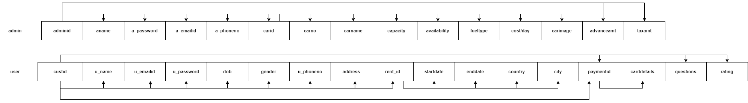

**FD Closure:**

1. adminid->a_name,a_password,a_phoneno,a_emailid,advanceamt,

taxamt,carid, carno,carname,pic,capacity,availability

1. custid->u_name,u_emailid,dob,gender,address,u_password,

country,city,carddetails,startdate,enddate,r_id,paymentid,rating,questions

1. carid ->carno,carname,pic,capacity,availability,fueltype,cost/day
2. r_id ->carid,carno,carname,country,city,startdate,enddate
3. paymentid ->carddetails,advanceamt,taxamt
4. adminid+->fueltype,cost/day(transitive rule)
5. custid+->advanceamt,taxamt(transitive rule)
6. custid+->carid,carno,carname(transitive rule)

**Attribute closure:**

**1.adminid**

● adminid={adminid,a_name,a_password,a_phoneno,a_emailid,advanceamt,taxa mt,carid} With transitivity rule,

carid->carno,carname,capacity,availability,fueltype,cost/day,carimage

adminid={adminid,a_name,a_password,a_phoneno,a_emailid,advanceamt,taxa mt,carid,carno,carname,capacity,availability,fueltype,cost/day,carimage}

**2.custid**

● custid={custid,u_name,u_password,u_emailid,dob,gender,address,rating,questio ns,rent_id,paymentid}

With transitivity rule,

rent_id -> country,city,startdate,enddate

paymentid -> carddetails,advanceamt,taxamt

custid={custid,u_name,u_password,u_emailid,dob,gender,address,rating,questio ns,rent_id,paymentid,country,city,startdate,enddate,carddetails,advanceamt,taxa mt}

**3.carid**

● carid={carid,carno,carname,capacity,availability,fueltype,cost/day,carimage}

**4.rent_id**

● rent_id={rent_id,carid,country,city,startdate,enddate}

With transitivity rule,

carid -> carno,carname,capacity,availability,fueltype,cost/day,carimage

rent_id={rent_id,carid,country,city,startdate,enddate, carno,carname,capacity,availability,fueltype,cost/day,carimage}

**5.paymentid**

● paymentid={carddetails,advanceamt,taxamt}

**Superkey:**

Since a single attribute does not determine all other attributes, composite superkey exists(adminid,custid)

**Canonical Cover:**

There are no extraneous attributes

● adminid -> a_name

● adminid -> a_password

● adminid -> a_phoneno

● adminid -> a_emailid

● adminid -> advanceamt

● adminid -> taxamt

● adminid -> carid

● custid -> u_name

● custid -> u_password

● custid -> u_emailid

● custid -> u_phoneno

● custid -> dob

● custid -> gender

● custid -> address

● custid -> rating

● custid -> feedback

● custid -> rent_id

● custid -> paymentid

● carid -> carno

● carid -> carname

● carid -> capacity

● carid -> availability

● carid -> fueltype

● carid -> cost/day

● rent_id -> carid

● rent_id -> country

● rent_id -> city

● rent_id -> startdate

● rent_id -> enddate

● paymentid -> carddetails

● paymentid -> advanceamt

● paymentid -> taxamt

**Checking for 1st Normal Form:**

➔ Primary key exists:(adminid,custid)(composite primary key)

➔ There exists no repeating group of columns.

➔ Some attributes are non-atomic(a_phoneno,u_phoneno)are multivalued attributes.

Since there are attributes that are not atomic,the relation is not in 1st normal form.To convert it into 1st normal form, combining the phone number into composite primary key and the multiple values can be added as separate rows.

**Schema in 1st normal form:**

Online_car_rent(adminid,custid,u_phoneno,a_phoneno,a_name,a_password,a_emaili d,u_name,u_emailid,dob,gender,address,u_password,carid,carno,carname,capacity,av ailability,cost/day,fueltype,carimage,questions,rating,rent_id,country,city,startdate,endda te,paymentid,carddetails,advanceamt,taxamt)

**Anomalies:**

1.Insert:New car details cannot be added without adding admin and rent details cannot be added without user.

2.Delete:If user details are deleted then the particular rent details will be deleted.

3.There is no update anomaly.

**Checking for 2nd normal form:**

➔ It is in 1st normal form

➔ Partial dependencies exists

**adminid** ->a_name,a_password,a_emailid,advanceamt,taxamt,carid, carno,carname,capacity,availability,cost/day,carimage

**custid**->u_name,u_emailid,dob,gender,address,u_password,country,city, carddetails,startdate,enddate,rent_id,paymentid,rating,questions

**u_phoneno and a_phoneno** 🡪does not determine non-prime attribute Part of the composite primary key determines non-prime attribute, so the partial dependencies exist here and therefore it is not in 2nd normal form. To convert it into 2nd normal form it can be split into 4 tables as follows.

**Schema in 2nd normal form:**

1)**adminid**(adminid,a_name,a_password,a_emailid,advanceamt,taxamt, carid,carno,carname,capacity,availability,cost/day) 2)**custid**(custid,u_name,u_emailid,dob,gender,address,u_password,country,city, carddetails,startdate,enddate,rent_id,paymentid,rating,questions) 3)**adminphonedetails**(adminid,a_phoneno,)

4 )**userphonedetails**(custid,u_phoneno)

**Checking for 3rd normal form:**

➔ It is in 2nd normal form

➔ Transitive dependencies exists

1)adminid ->carid ->carno,carname,capacity,availability,fueltype,cost/day

2)custid ->paymentid ->carddetails

3)adminid ->paymentid ->advanceamt,taxamt

4)custid ->rent_id ->country,city,startdate,enddate

Since non-prime attribute determines other non-prime attributes, so transitive dependency exists.Hence the relation is not in 3rd normal form, making it into 3rd normal form.

**Schema in 3rd normal form:**

1)admin(adminid,a_name,a_password,a_emailid) 2)user(custid,u_name,u_emailid,dob,gender,address,u_password,questions,rating) 3)adminphonedetails(adminid,a_phoneno,)

4)userphonedetails(custid,u_phoneno) 5)cardetails(carid,carno,carname,capacity,availability,fueltype,cost/day,carimage) 6)rentdetails(rent_id,carid(fk),custid(fk),country,city,startdate,enddate) 7)paymentdetails(paymentid,rent_id(fk),carddetails,advanceamt,taxamt)

**BCNF**:

➔ It is in 3rd normal form

**Functional dependencies:**

adminid ->a_name,a_password,a_emailid

custid ->u_name,u_emailid,dob,gender,address,u_password,questions,rating

u_phoneno ->custid

a_phoneno ->adminid

carid ->carno,carname,capacity,availability,fueltype,cost/day,carimage

rent_id ->carid,country,city,startdate,enddate

paymentid ->carddetails,advanceamt,taxamt

**Candidate Keys:**

➔ For the first relation:adminid

➔ For the second relation:custid

➔ For the third relation:adminid,a_phoneno

➔ For the fourth relation:custid,u_phoneno

➔ For the fifth relation:carid

➔ For the sixth relation:rent_id

➔ For the seventh relation:paymentid

It is in bcnf because the left side part of the functional dependencies is a key

**Checking if decomposition is lossless and dependencies are preserved:**

Let each relation be denoted by(R1...R7)

R1:admin(adminid,a_name,a_password,a_emailid) R2:user(custid,u_name,u_emailid,dob,gender,address,u_password,questions,rating) R3:adminphonedetails(adminid,a_phoneno,)

R4:userphonedetails(custid,u_phoneno) R5:cardetails(carid,carno,carname,capacity,availability,fueltype,cost/day,carimage) R6:rentdetails(rent_id,carid(fk),custid(fk),country,city,startdate,enddate) R7:paymentdetails(paymentid,rent_id(fk),carddetails,advanceamt,taxamt)

# [Lossless Decomposition](https://docs.google.com/spreadsheets/d/19RnKV0Q1Zl1_bG73mwwv-uiCl86yegbMaofDolMh61A/edit?usp=sharing)

Since all dependencies are taken care of by relations 1 to 7, it is dependency preserving

# Final functional dependency diagram:

# 

# Chapter 5 Creation of Tables

**Admin table:**

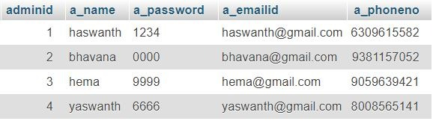

**Car details:**

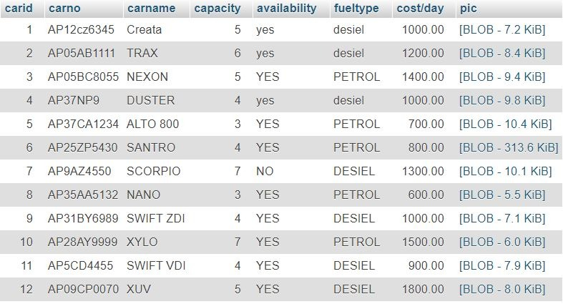

**Enquiry Table:**

# 

**Feedback Table:**

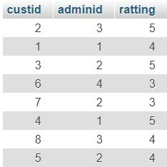

**User phoneno Table:**

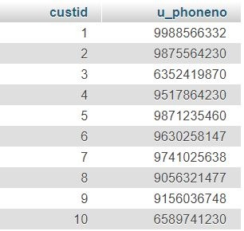

**Payment details Table:**

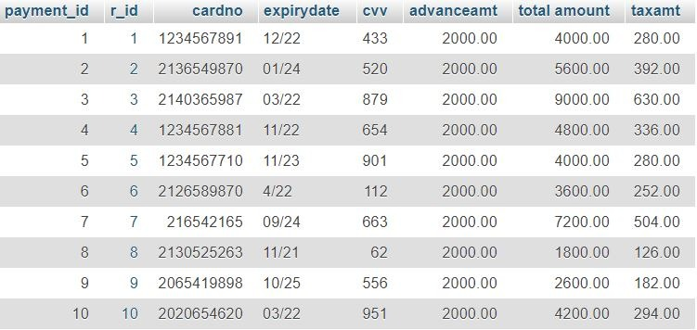

**Admin phoneno Table:**

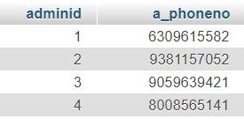

**Rent details Table:**

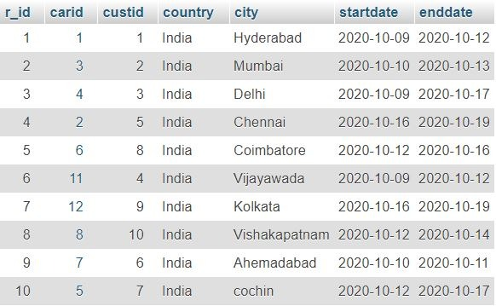

**User Table:**

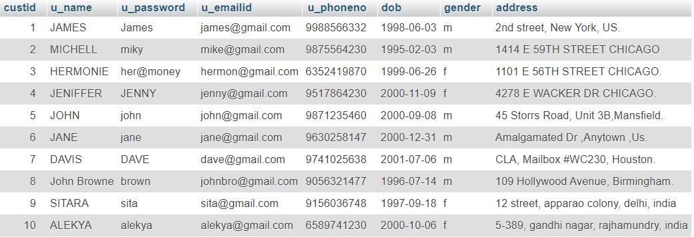

# Chapter 6 User Interface Design

**UI screens for data entry into all the tables.**

**Signup page:**

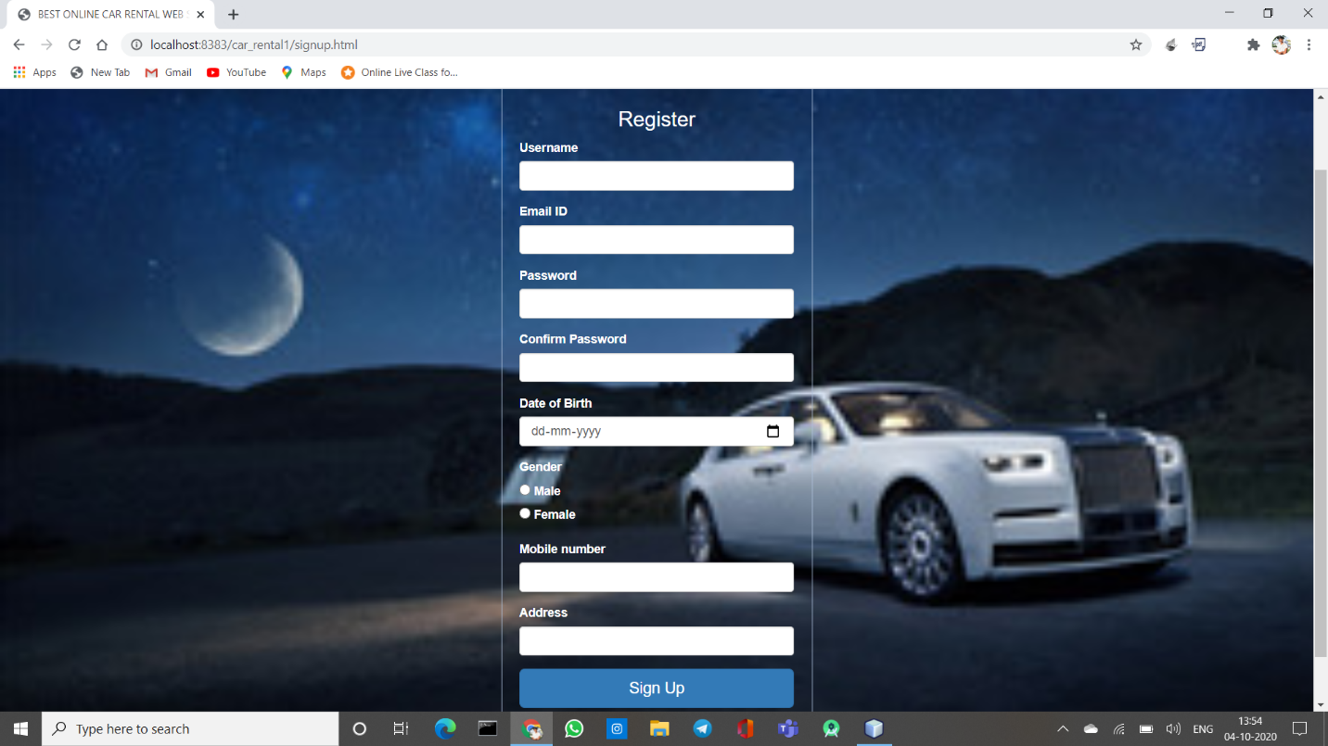

**Rent a car page:**

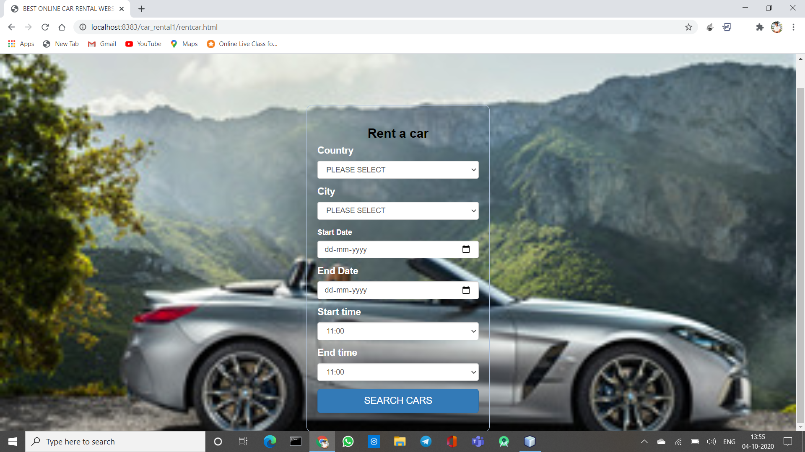

**Queries page:**

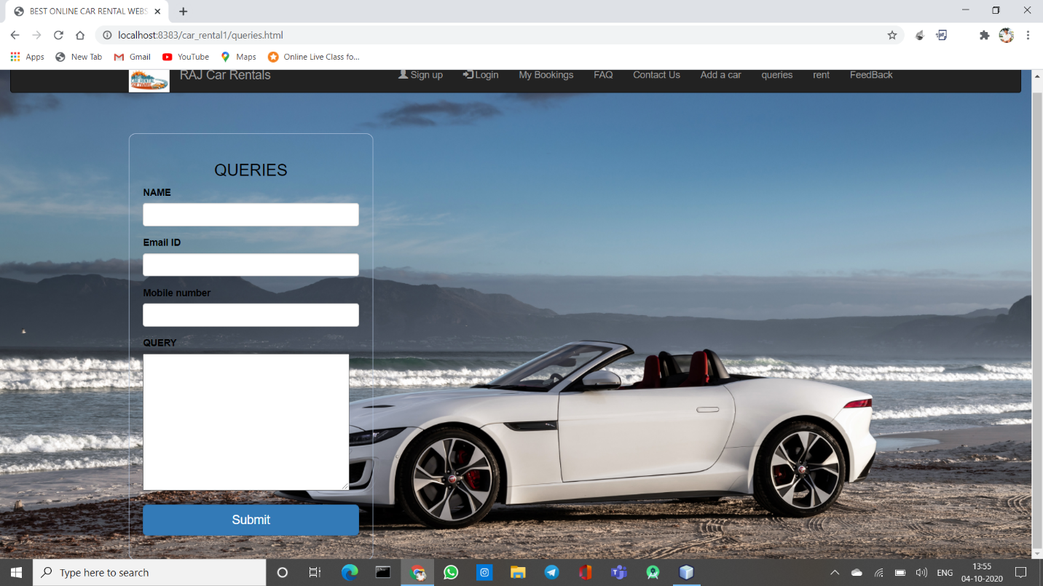

# Login page:

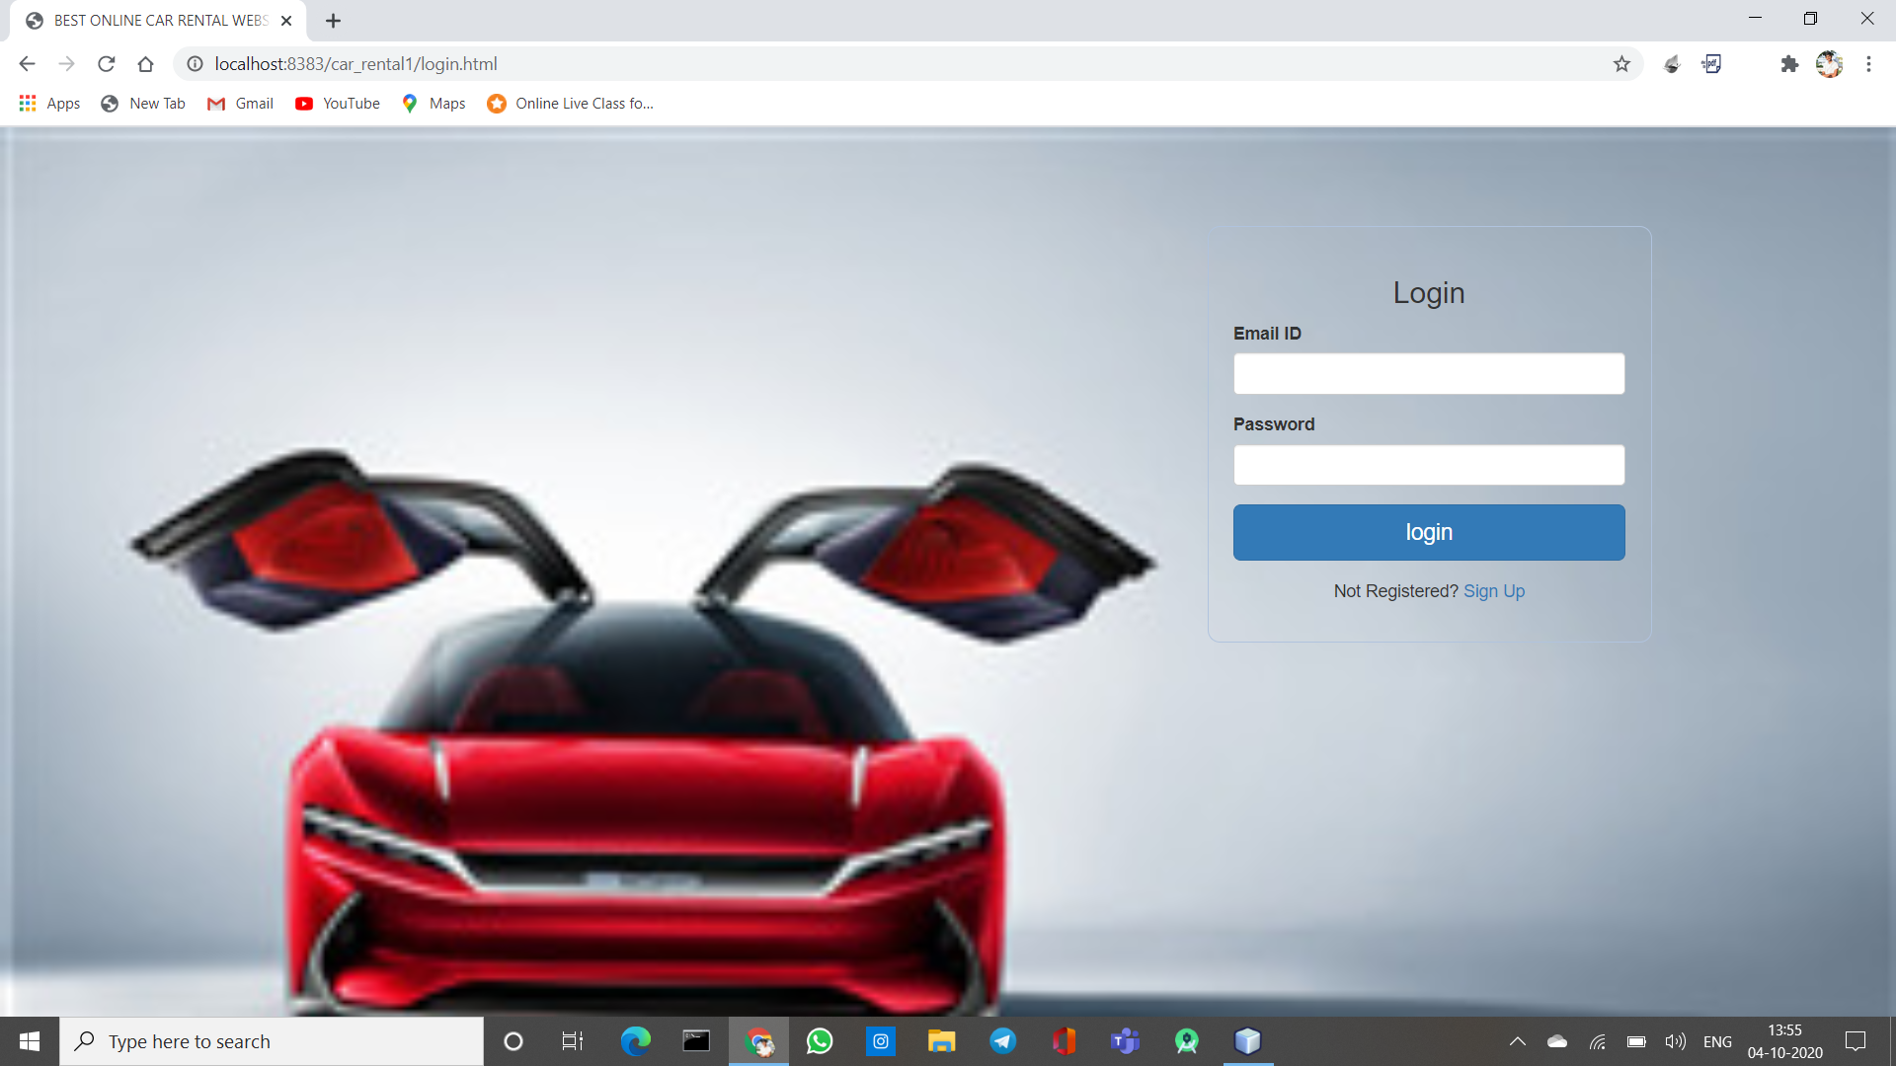

**Car details page:**

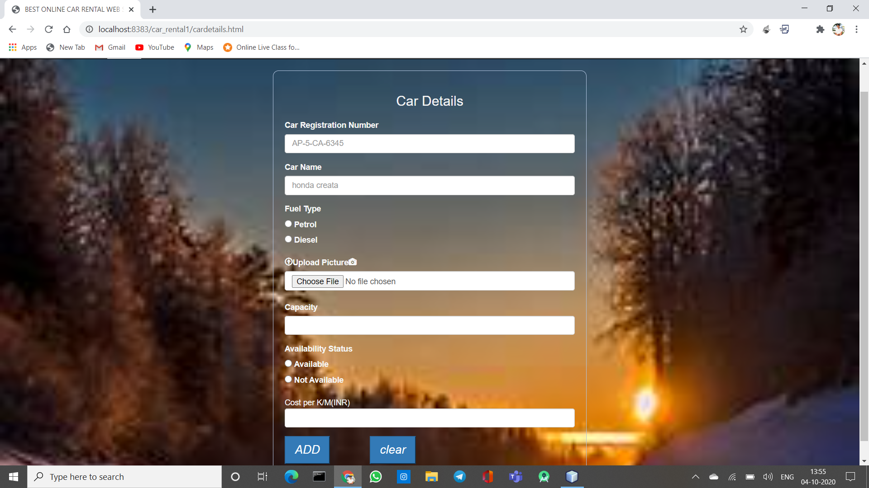

# Payment page:

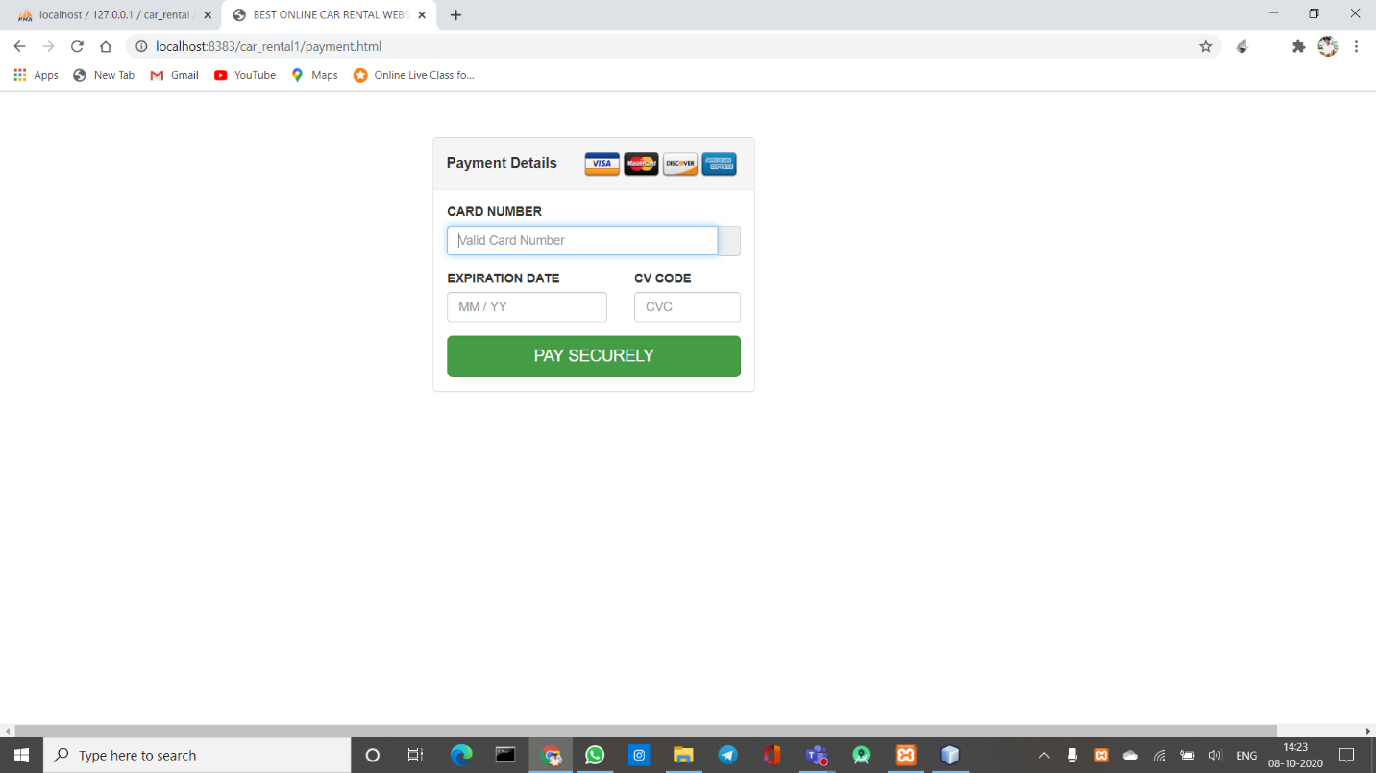

**Feedback page:**

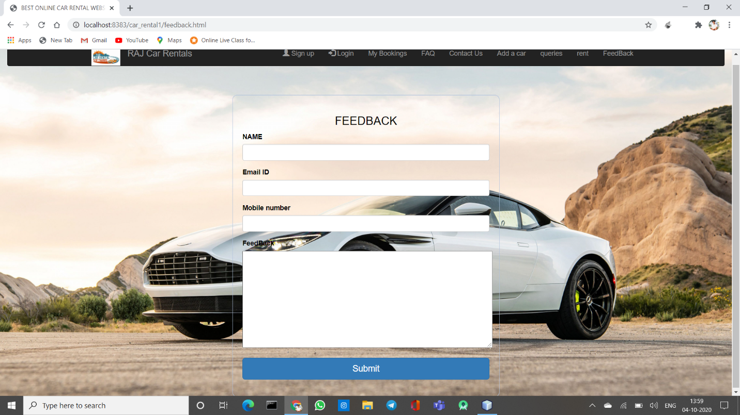

# References

**Books reference format**

* Abraham Silberschatz , Henry F. Korth , S. Sudarshan Database System Concepts. 6th ed. New York: 1-December-2013

**Websites reference format**

* **Data Base system concepts**